Lesson 23
1. C
2. a-True
b-false
c-false
3.Amela is right. 1 1/2 is thrice 1/2 if you divide 1 1/2 by 1/2 you will get 3
4. 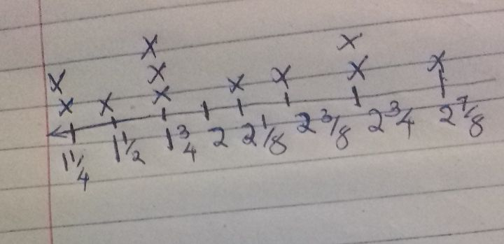
solving problems using data in a line plot
1. 5/8
2.3 1/4
3. 2 1/3
4. ¼
5.1 ¾
6. 2 ¾
7. 11 inches
8. 30 ½
practice b
1.= 3+(6x4)
= 3+24
= 27
2. = (2 5/5)-2
= 5-2
= 3
3.
8-(2x3)
= 8-6
= 2
4. = 6-(6/3)
= 6-2
= 4
5. = 21-(5+7)
= 16+7
= 23
6. = (6x2)+4
= 12+4
= 16
7. = 12-(8/2)+3
= 12-4+3
= 8+3
= 11
8. = 21/7= 3
=14*2=28
= 3+28
= 31
9. =(4/4) x 4+4-4
= (1x4)+4-4
= 4+4-4
= 8-4 = 4
10. = (8/4)=2
= 7+3*(2)
= 7+3x2
= 7+6
= 13
11. = (8-3)=5
= 20/(5)+16
= 20/5+16
= 4+16 = 20
12. = 32/[(4+4)/2]
=(4+4)=8
= 32/[(8)/2]
= 32/[8/2]
=[8/2]=4
= 32/[4]
= 32/4 = 8
13. >
14.>
15.=
16.>
17. <

